CAPSTONE PROJECT

THE BATTLE OF NEIGHBORHOODS – A COMPARATIVE STUDY OF THE EARLIER SIX LOWER-TIER CONSTITUENT MUNICIPALITIES OF TORONTO

INTRODUCTION

**Toronto is the** capital of the province of Ontario and the business and financial capital of Canada. It’s a multicultural city, and a growing financial hub in North America.

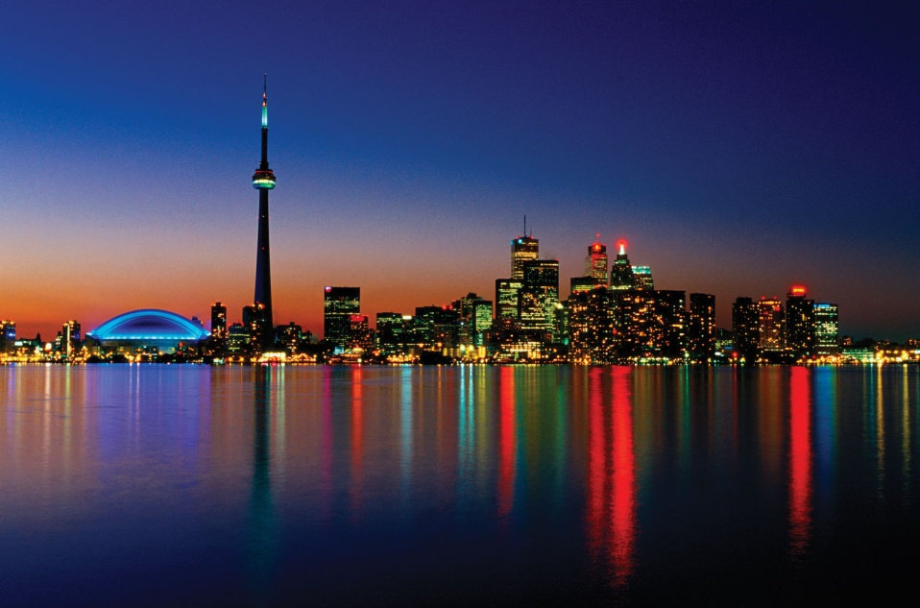

The City of Toronto

On January 1, 1998, Toronto was greatly enlarged, as an amalgamation of the Municipality of Metropolitan Toronto and its six lower-tier constituent municipalities; East York, Etobicoke, North York, Scarborough, York, and the original city itself. They were dissolved by an act of the Government of Ontario, and formed into a single-tier City of Toronto.

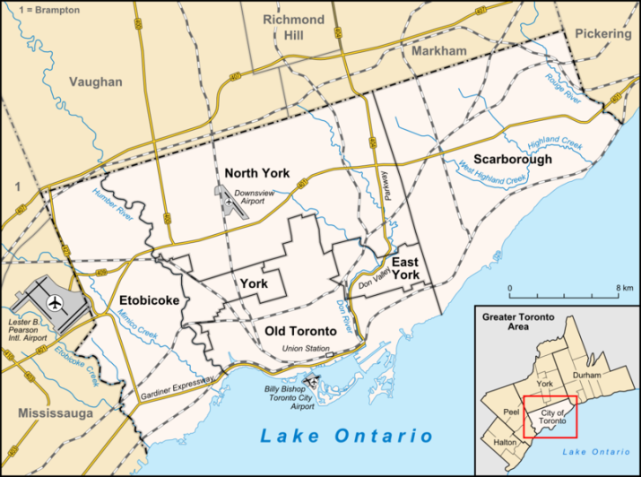

The Map of Toronto showing Old Toronto and its six lower-tier constituent municipalities

The present work was carried out with a view to suffice the understated business problem.

People, their needs and choices are highly dependent on the region they live in. The flourishment of a particular business is highly dependent on these factors. But it also depends on the market’s competency. Venturing a business start-up in an area where that business has already mushroomed may not be as fruitful as implementing the same idea in a market with lesser competitors. At the same time, choosing a market without any competitor, with a view to establish monopolistic competition, without gauging the mindsets of the residents can prove to be deceptive. With all these ‘words of wisdom’ hovering over a businessman’s head, he may wish **to get the business analytics of the different areas where he wishes to set up his new, so that he can both efficiently as well as effectively choose the most appropriate area for the same**.

The presented capstone project aims at furnishing a comparative study of the earlier six lower-tier constituent municipalities of Toronto, namely, East York,  Etobicoke, North York, Scarborough and York to analyze the business prospects in each one.

DATA

It’s the extraction and efficient processing of datasets, collected from various sources, that makes up the bulk of a ‘data scientist’. What good is a data scientist without data? Collecting and wrangling data requires a lot of practice, patience and dedication. All datasets are unique in their own way, and each one requires a new approach.

In this capstone project, I used the data from the following sources.

1. Wikipedia: Wikipedia is a repository of a huge volume of data. The data for the different boroughs of Canada is readily available by clicking on the link given below.

<https://en.wikipedia.org/wiki/List_of_postal_codes_of_Canada:_M>

The data was extracted as a pandas dataframe, in the form as shown.

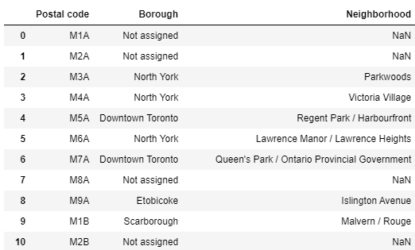

We can see that many of the boroughs have not been assigned. Hence, the next thing to be done was to drop all the rows that had no boroughs assigned. Also, any neighborhood, that didn’t have a value, was assigned its corresponding borough. The slash (/) for more than one neighborhood for a given borough was replaced by a comma (,). After all this, the dataframe looked like:

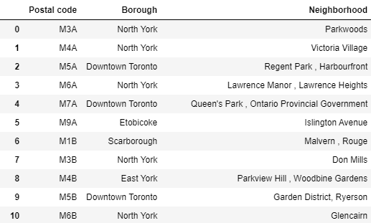

1. <https://cocl.us/Geospatial_data>

This link provided the geographical coordinates, i.e., the latitude and longitude of each Postal Code in Canada. A snapshot of the data collected from this site is given below.

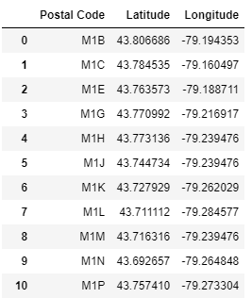

The data obtained from Wikipedia was merged with the dataset shown above, to get the following dataframe.

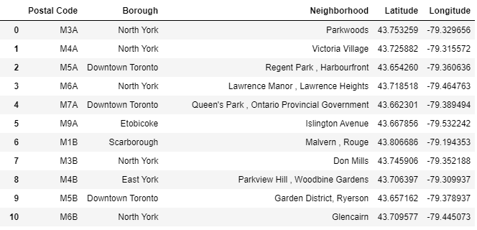

The above dataframe was used for classifying the earlier six lower-tier constituent municipalities of Toronto.

1. Foursquare API: Foursquare is a social location service that allows users to explore the world around them. The Foursquare API allows application developers to interact with the Foursquare platform. The API itself is a RESTful set of addresses to which one can send requests, so there's really nothing to download onto the server.

Foursquare API was used in this project to get the common venues around each of the six places, by passing in the required parameters.

The dataset was of the following form:

